* **Created a database named “todo”**

use todo

* **Inserted one record to a table named tasks_table**

**Table contains task_name,time(start,end),status of the task**

db.tasks_table.insertOne({task_name:"Attend Class", time:{start: new Date("2025-05- 28T10:00:00Z"), end: new Date("2025-05-28T18:00:00Z")}, status:"pending"})

* **to see the contenst of table**

db.tasks_table.find()

* **inserting records one by one**

db.tasks_table.insertOne({task_name:"Submit Assignment", time:{start:new Date("2025-05-28T11:30:00"), end:new Date("2025-05-28T12:00:00")}, status:"done"})  
added on

db.tasks_table.find()

db.tasks.insertOne({task_name: "Study MongoDB", time: {start: new Date("2025-05- 28T14:00:00Z"), end: new Date("2025-05-28T15:00:00Z")}, acknowledge: "pending"})

db.tasks_table.find()

db.tasks_table.insertOne({task_name: "Study MongoDB", time: {start: new Date("2025-05- 28T14:00:00Z"), end: new Date("2025-05-28T15:00:00Z")}, acknowledge: "pending"})

db.tasks_table.find()

db.tasks_table.insertOne({task_name: "Check Results", time: {start: new Date("2025-05-28T15:15:00Z"), end: new Date("2025-05-28T15:30:00Z")}, acknowledge: "done"})

db.tasks_table.find()

db.tasks_table.insertOne({task_name: "Join Teams call", time: {start: new Date("2025-05-28T13:50:00Z"), end: new Date("2025-05-28T17:30:00Z")}, acknowledge: "pending"})

db.tasks_table.find()

* **Inserting multiple records at a time**

db.tasks_table.insertMany([{task_name: "Assignment", time: {start: new Date("2025-05-28T18:00:00Z"), end: new Date("2025-05-28T19:00:00Z")}, acknowledge: "pending"}, {task_name: "Lunch break", time: {start: new Date("2025-05-28T13:00:00Z"), end: new Date("2025-05-28T13:30:00Z")}, acknowledge: "pending"}])

db.tasks_table.find()   
  
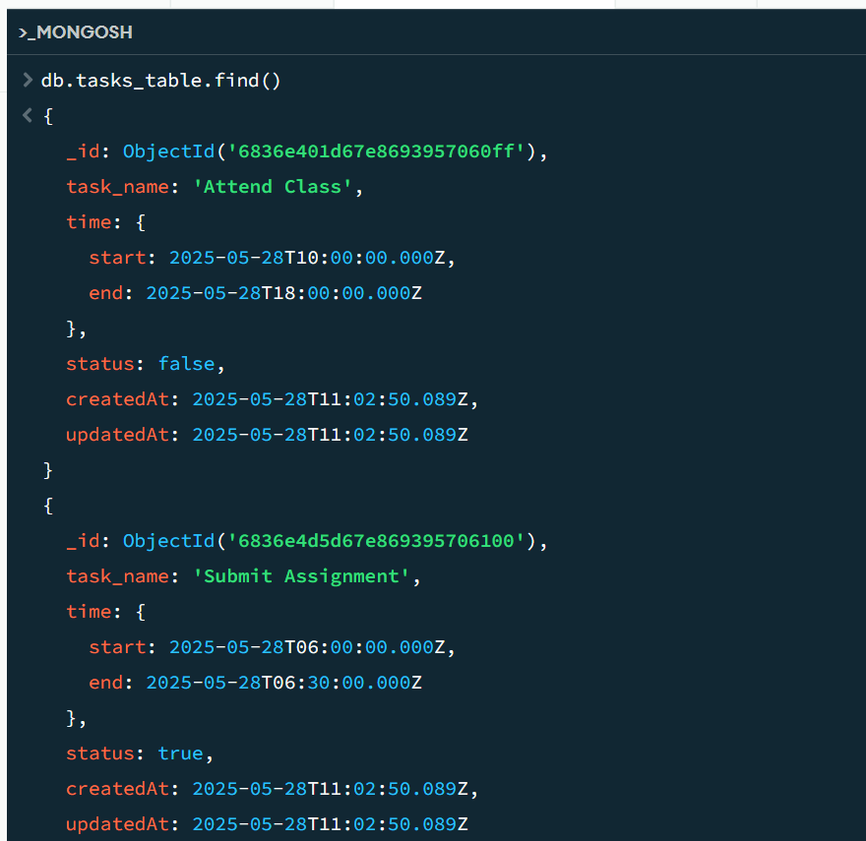  
  
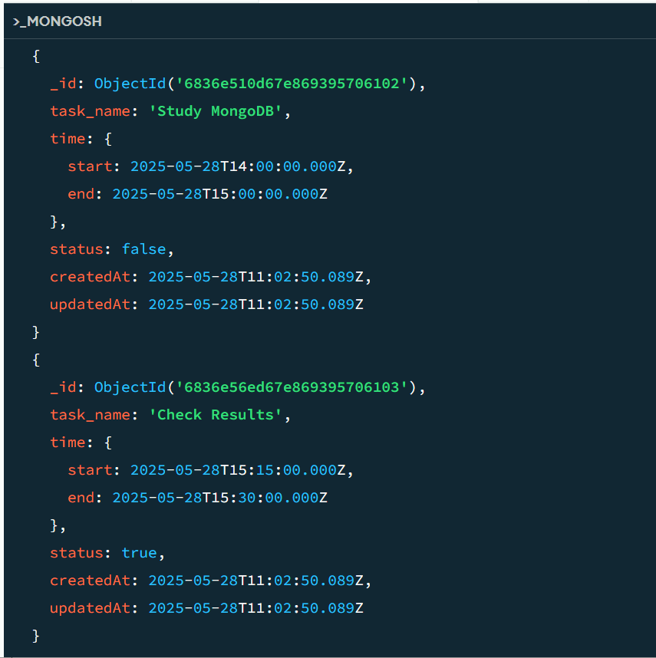  
  
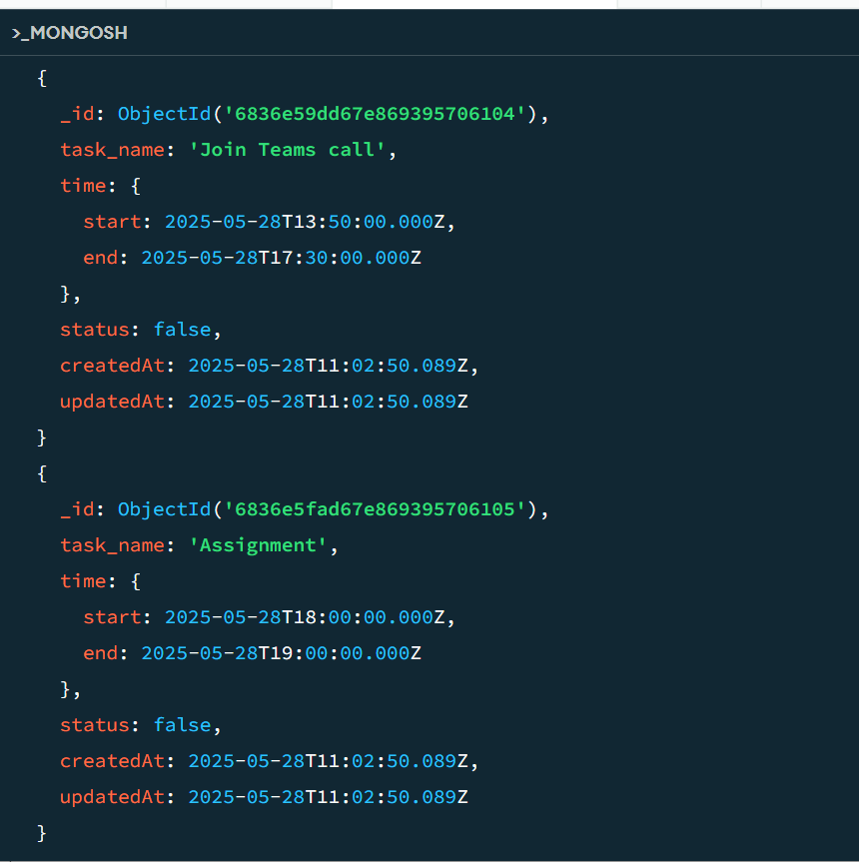  
  
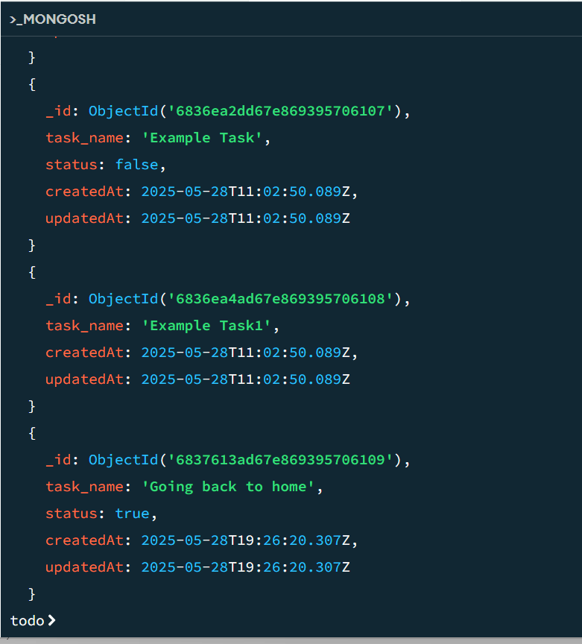

* **Changing some acknowledge fields of a records to “status”**

db.tasks_table.updateMany({ acknowledge: "done" }, { $set: { acknowledge: true } })

* **Changing “status” pending or done to Boolean true or false**

db.tasks_table.updateMany({ acknowledge: "pending" }, { $set: { acknowledge: false } })

db.tasks_table.find()

db.tasks_table.updateMany({ acknowledge: { $exists: true } }, { $rename: { "acknowledge": "status" } })

db.tasks_table.find()

db.tasks.updateMany({ status: "done" }, { $set: { status: true } })

db.tasks_table.find()

db.tasks_table.updateMany({ status: "done" }, { $set: { status: true } })

db.tasks_table.find()

db.tasks_table.updateMany({ status: "pending" }, { $set: { status: false } })

db.tasks_table.find()

db.tasks_table.find().pretty()

* Setting Default status False

db.tasks_table.insertOne({task_name: "Example Task", status: false})

db.tasks_table.find()

db.tasks_table.insertOne({task_name: "Example Task1"})

db.tasks_table.find()

* **Adding “createdAt” and “updatedAt” field to records**

db.tasks_table.updateMany({}, {$set: {createdAt: new Date(), updatedAt: new Date()}})

db.tasks_table.find()

* **Altering the status of a record and changing the updatedAt field**

db.tasks_table.updateOne({ task_name:'Lunch Break' }, {$set: {status: true, updatedAt: new Date()}})

db.tasks_table.find()

db.tasks_table.updateOne({ task_name:"Lunch Break" }, {$set: {status: true, updatedAt: new Date()}})

db.tasks_table.find()

db.tasks_table.updateOne({ task_name: "Lunch break" }, {$set: {status: true, updatedAt: new Date()}})

db.tasks_table.find()  
  
**To find the no of records with status “True”**

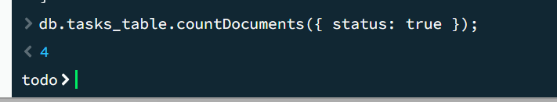  
  
  
**To find which records are with status “True”**  
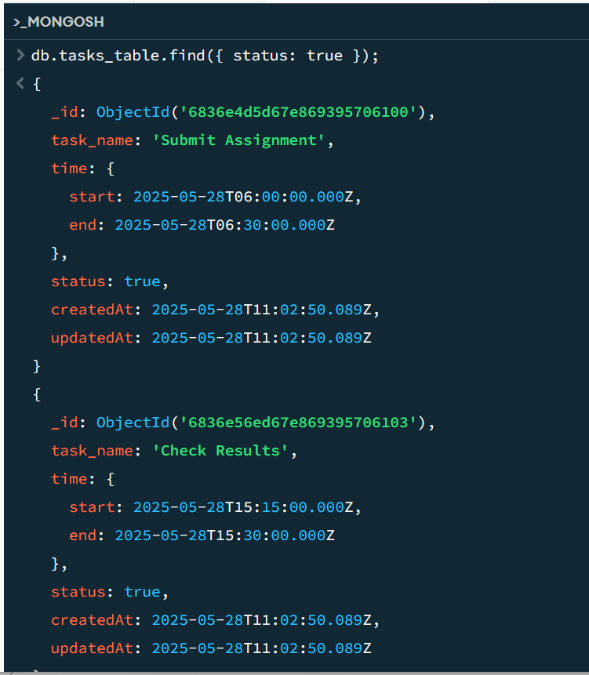

* **To get the records which are created in last 20mins**  
  db.tasks_table.find({createdAt: {

$gte: new Date(Date.now() - 20 * 60 * 1000)}

});  
**here Date.now() gives the current time in milliseconds so we are subtracting 20min by converting into milliseconds,to get the records which are created greater than or equal to 20minutes  
  
  
